KNIGHT OF THE ROSE CROSS Degree EIGHTEEN
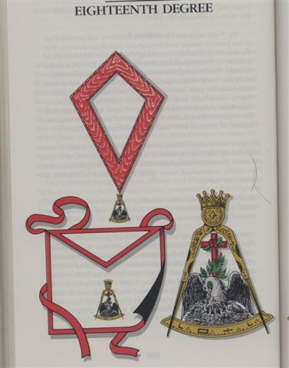
Translated from the Spanish Edition 2005

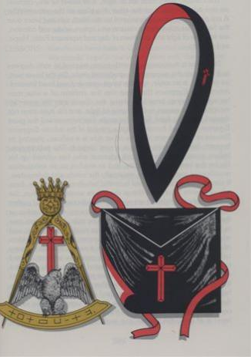
The Apron is made of white satin edged with crimson on one side and completely black on the other. On the white side the jewel pelican is embroidered. On the black side there is a big red cross of passion.
The collar, worn from left to right, is made of velvet or silk, crimson on one side and black on the other; it's empty on the crimson side. A red cross of passion is embroidered on the black side and worn over the heart. The colors of the collar and apron, white and crimson, are symbols of the light and the dawn of the day and represent Faith, Hope and Charity.

The jewel is the compass with points open at 60º and resting on the segment of a graduated circle. The lowest part, on one side, is an eagle, with its wings spread and its head bowed. Among the Egyptians the eagle was the emblem of the wise man because his wings carried him above the clouds to the purest atmosphere and close to the source of light, and his eyes were not blinded by that light. As the eagle also represented the Great Egyptian God the sun Amun Ra, she is a symbol of the infinite Supreme Reason or Intelligence. On the other side there is a pelican wounding his chest to feed his seven chicks that are in the nest below him. The pelican symbolizes every philanthropist and reformer who has offered his life for the good of humanity, and thus teaches us an inexhaustible munificence towards all men, especially the needy and defenseless. It also represents the great and exuberant exuberance of nature, from whose bosom all created things derive their sustenance. Thus, the pelican and the eagle together are symbols of perfect wisdom and devotion. There is a crimson cross displayed on both sides; at the intersection of his arms, on the side of the pelican, there is a red rose in bud. The cross, pointing towards the four cardinal points, and whose arms, infinitely extended would never meet, is an emblem of space or infinity. The cross has been a sacred symbol in many cultures since ancient times. The rose was formerly consecrated to the sun and Aurora, the Greek goddess of dawn. As a symbol of the morning light, she represents resurrection and renewal of life, and therefore immortality. Together the cross and the rose symbolize the immortality gained through suffering and pain. At the apex of the compass there is an ancient crown. Above the segment of the circle, on the side of the pelican, is the word of this degree in a special encrypted language. This jewel is made of gold; the pelican and the eagle on it are silver.

DUTIES: Practice virtue as this can produce fruit. Work to eliminate vice, purify humanity. Be tolerant of the faith and beliefs of others mistakes and faults of others.

LESSONS: We must have faith in God, humanity, and ourselves.
We mus to have confidence in victory over evil, the advancement of humanity and the future.
Charity is satisfying desires and tolerating the errors of others.

FOR REFLECTION: Are there evil and calamity to give an opportunity to practice virtue?
Do your attitudes and actions reflect Faith, Hope and Charity?

IMPORTANT SYMBOLS: The constellations called Faith, Hope and Charity, the punishments and terrors of Hell, the rose, the cross, the pelican and the eagle.

This Degree prepares the advent of the New Law, the Law of Love, proclaimed in unequivocal terms by Jesus of Nazareth after centuries of spiritual and intellectual darkness in the world in which the Sacred Word was lost again. The supreme message brought to the world at that time was the proclamation of the Fatherhood of God and the Brotherhood of Man. This proclamation, although presented by a specific figure, is not to be taken as an invocation of a particular religious belief.

Tolerance is also taught when we are led through a myriad of examples from the many and diverse beliefs of the ancients who teach us that neither the cross as a symbol nor the notion of a Messiah is exclusively Christian. They are manifestations of religious truths appropriate to the people who perceived them. From these examples, we can conclude that tolerance is not simply a duty, but an unavoidable conclusion. The instructions on the concept of a Messiah are suggestive only and should not be taken as the official doctrine or dogma of Freemasonry in general, or the Scottish Rite in particular; the religious proof of Masonry is too universal to admit such a claim.

Ceremony

As in the previous compulsory Degree, Fourteen, there is no deception here. The candidate is led through three apartments. The first describes the world in chaos under the tyranny of evil. Officers sit on low stools among the scattered ruins of columns and tools of the Symbolic Lodge. The officers show despair, pain, and repudiation that the Holy Word has been lost again. The candidate enters this apartment lost in the mists of darkness, error and false philosophy - confused among the ruins of the old system of thought. The ebony crucifix (black meaning evil, darkness) represents the world's treatment for those who dare to make the truth known. The Lost Word, one recalls, is representative of many things - the loss of reason, intellect, and moral sense and the loss of a true conception of deity. In the world represented in this apartment, Man has made not only God, but also the devil, in his own image.

The candidate is questioned as to whether he will join the others who have labored in vain day and night in search of the Lost Word, the Key to the Terrible Labyrinth. After the affirmative response of the candidate to enter his search, three “constellations” appear - shining in the pillars: Faith, Hope and Charity - to guide towards the exit from the rudeness of doubt, fainting and despair.

The reference to the virtues of Faith, Hope and Charity as
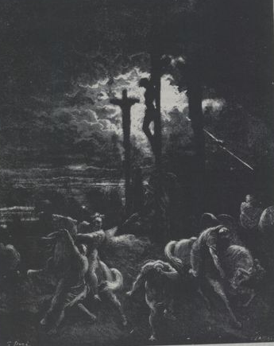
"Constellations" can admit more than an interpretation; by consequent, the following should be taken alone as an example to stimulate the mind towards a higher reflection. In time ancient men believed that some planets, stars and constellations and their positions in the heavens ruled the affairs of the men, producing beneficial tendencies or malignant tendencies in the course of fate that men could propitiate or try to avoid, often to no avail. In Freemasonry men’s lives are ruled, or should be ruled by the constellations of virtue, sought after in the East - the source of light and knowledge. It is for this reason that the cover of this book is a oriental motif. Soon the constellations disappear and darkness reigns again:

And so it is that faith and mistrust, and hope and doubt always alternate, like day and night, like summer and winter.

The search continues; the candidate travels around the Lodge. In the North, a traditional place of darkness, is the second apartment. The paintings or transparencies describe the punishments and terrors of Hell, similar to those seen by Dante or Milton. The tablets illustrating the consequences of sin and vice admit of various levels of meaning and interpretation. For some, they are real representations of the destiny and punishment that awaits those who break God's Laws; for others, they are only a symbol of earthly destiny and punishment. But for everyone, they should be a reminder of the Law of cause and effect that cannot be repelled:

The word once said, the act once performed, they are forever; and its consequences, good or bad, are immortal.

More specifically the flames symbolize the passions that infect the hearts of men against which Masonry has always battled.

The search continues both for the True Word and for the explanation of the great enigma of the Universe; that is, how to reconcile the existence of sin and wrongdoing, and the pain and suffering of the world, the prosperity of the fortunate and powerful, the unspeakable injustices and deceptions, the emptiness and superficiality of some religious creeds? Why does evil exist: natural evil, such as famines, earthquakes, and droughts, and moral evil, such as murder and tyranny?

During the search, we learn the Masonic meaning of the initials INRI on the Cross of Christ made by artists as a representation of the real message found in John 19:19. Nature is both allegorical and factual, figurative and literal, symbolic and real. It is a sacred writing of the Mason and on it God has written his teachings for man to learn. Science is not the enemy of religion but rather the highest expression of it - knowing and understanding the mysteries of God's Universe.

Man's ability to express the concept of infinity is his own evidence of the divine spark in the human intellect: the numbers parade before us, endless but countable; the space extends beyond our ability to see but still we patiently reveal its secrets one by one; the attributes of God are the infinite extensions of the virtues of man.
The hope of immortality is the beginning of religion. We see its evidence in the most primitive cultures. All the major religions of the world promise immortality in the presence of God to justify virtue and the longing for immortality without God inhibiting it. We teach that immortality is a natural consequence of the character of the soul itself, as Pike says:

The spirituality of the soul is the necessary condition and foundation of immortality; the law of merit and demerit the direct demonstration of them. The first is the metaphysical proof, the second the moral proof. Add to these the tendency of all the powers of the soul toward Infinity, and the principle of final causes, and the proof of the immortality of the soul is complete (p. 706).

Reason separates humanity from other forms of life; it's a gift. The spider can weave a beautiful web, but it is not an artist; the bee can dance its messages but that is not ballet; termites build great citadels but they are not engineers. Only man possesses the divine spark of the intellect and therefore reasons. The gift of reason is not, however, a gift of ease and indulgence - it requires the greatest effort and is thus often wasted almost entirely. The vast majority of humanity makes little or no use of this divine gift, choosing rather the simple life of physical work occasionally interrupted by periods of time devoted to hobbies or passive recreation.

The third apartment represents the universe that shines with the true light of the Supreme Deity and free from the principle of evil. In this chamber the instruction provides various interpretations for the existence of evil that have been created by philosophers and theologians of the past. Whether one chooses to accept the concept of evil as the shadow of good or as the evil influence of a personified evil principle, such as Satan, or as the opportunity for the practice of virtue in the face of adversity, is a matter. on which Masonry does not judge.

It is important to remember that not all the great mysteries have been satisfactorily solved by man's searches; and the existence of evil is one such mystery. Neither philosophy, religion nor Masonry have given an answer to this great enigma that could be said to satisfy everyone. It is, for the moment, sufficient to recognize that both natural and moral evil exist and that much of this evil can be overcome through simple human action. Let those thus inclined to spend their time contemplating such mysteries, for the vast majority of us it remains true to simply fight evil and make this world the best we are capable of. It is not for Masonry to make determinations of truth about these interpretations, especially in this Degree that teaches tolerance. When revisiting this Degree, one should pay particular attention to these interpretations, so that each one can find within them a meaning more closely aligned with his own beliefs. At the same time, one can be gifted with the opportunity to refer to them later.

Also in this Chamber the Law of Love is recognized as the simple but sublime expression of the divine nature. Man discovers that God is not a tyrant before whom men must tremble, but is like a father, infinitely wise and good, pious and loving.

Significant Symbolism

The symbolism here is made up of reminders of previous Degrees, hints of future Degrees, and the symbols of the three great virtues taught in this Degree - Faith, Hope, and Charity.
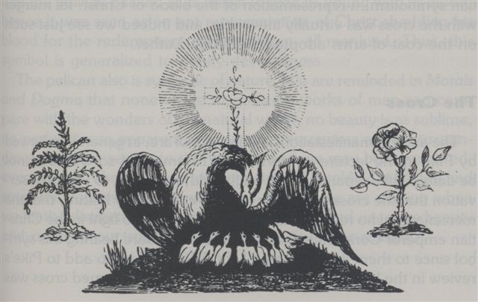
The Rose

Many mystical systems have found an important symbol in the rose. Its use as a Masonic symbol is therefore the continuation and expansion of an ancient tradition. In the Greek mysteries of Iacchus, the white rose was a symbol of silence, a virtue of the Fourth Degree. In classical mythology the color of the red rose is attributed to a white rose that has been sprinkled with the blood of Venus wounded by a thorn while trying to help her son Adonis who had been attacked by a wild boar. Of course there are other legends as well.

In Masonry the rose has assumed the meaning of immortality. Surely the idea of ​​immortality is as old as rational man. The Neardenthales buried their dead with their possessions, possibly believing that the deceased still needed them. The oldest mythologies speak of men made gods, who reign forever in the heavens. Immortality is the quintessential hope of all humanity. For many it is the true source of virtue, for others only an absurd superstition; therefore, Masonry teaches only the hope of immortality, but even the literature of the Order abounds with the expression of the immortality of the soul and time has turned it into a creed, if not a doctrine.

Both references to the rose in the Bible, in the King James version are suspect: the reference in Isaiah 35: 1 says “lily” in the Latin version of the St. Jerome Vulgate, and contemporary scholars (eg Anchor Bible ) identifies "the rose of Sharon" in Song of Songs 2: 1 as a saffron. Despite all this, the rose came to be in Christian symbolism, a representation of the blood of Christ. His mixture with the cross was virtually inevitable; and we even see such a mixture in the coat of arms adopted by Martin Luther.

The Cross

The old manifestations of this symbol are, in general, reviewed by Pike in the reading of Morals and Dogma so that we do not need to repeat them. We could add, however, to Pike's observation that the cross was a sign of the Persian Deity Mirtha, that the mercenaries who revered this god were thus able to fight in the armies of the Christian Emperor Constantine under a banner bearing this symbol because for them he represented light. We will also add to Pike's opinion in the reading for this Degree that the equal-armed cross was a symbol of the medieval alchemists for whom it represented the four elements: air, earth, fire and water. Even in its oldest representations, that is, pre-Christian, the cross may be associated with love as an integral part of the astrological symbol of Venus, the Roman deity of that virtue; the presence of similar cruciform representations as part of the symbols of Mercury, Mars, Jupiter and Saturn make it possible to affirm that it could first appear in other symbols and that it testifies to the diversity of symbolic meanings of the cross.

The cross in Masonry is an affirmation of infinity. This concept, and the word we use to describe it, contains within the limits of its meaning some of the most profound thoughts in philosophy and science. He forces our minds to the limits of human understanding, conjuring visions of numbers that stretch out endlessly before us, a Universe that has no borders, time stretching without limit in front of and behind us, and, above all, the overwhelming attributes of God. . The idea of ​​the infinity of God's attributes may be impossible for man to understand but the search for such understanding is his own noble work.

The Pelican

This symbol is derived directly from early Christian art and represents Christ. As a Christian symbol, it has its origin in the belief that the Pelican wounded his chest to feed his chicks with his blood; hence it was seen as an adequate representation of Christ offering his blood for the redemption of his children, all of humanity. Thus this symbol became generalized to signify devotedness.

The pelican is also symbolic of nature. In Morals and Dogma we are reminded that none of the magnificent works of man can compare with the wonders of the natural world; no beauty is so sublime, no perfection so evident. The very commonness in our surroundings fill our senses and blind them to this wonder and we can become bored, even cynical about the beauties of nature. The old adage "stop and smell the flowers" should remind us of what we are missing when we let the distractions and cares of the world blind us to the beauty and order of our surroundings, God's gift to our senses.

The Eagle

Like the rose, this emblem is of great antiquity, appearing in the symbolic inventory of the Egyptians, like the sun; of the Hebrews Jehovah; of the Romans, wisdom. Christians saw the eagle as the pelican as a representation of Christ who carried his children on his wings, teaching them, for example, truth and love and leading them to a more spiritual conception of life. For Pike it also meant freedom, probably because of his presence on the shield of the United States; the bald eagle was selected rather than Benjamin Franklin's suggestion of the turkey.

As wisdom is achieved through reason, the eagle is also a symbol of reason, the only attribute of man among all the creatures in the world. Through reason we have come to understand the mechanics of the natural world, established societies united by custom and law, created great works of literature and art, discovered many of the mysteries of the human mind, and secured at least a progressive understanding the nature of deity and our place in the universal plan. It remains for us to channel their power toward better goals, alleviate human misery and suffering, end the torture of war, and remove the chains of vice.

The Pillars

For Pike, faith corresponds to beauty, that attribute that is one of the supports of the Symbolic Lodge. We can also see it as a symbol of one of the greatest teachings of this Degree: the unity, immutability and goodness of God.

Similarly, hope is said to represent strength, to which we must tie the teaching of the immortality of the soul, perhaps humanity's greatest hope.

And finally it is said that charity means wisdom, involved here in teaching the concept of a redeemer who, in any religion, is the highest manifestation of God's love for man.

In addition to the three theological virtues of Faith, Hope and Charity, we must not lose sight of the true Masonic virtues - love brotherly, help and truth taught in the Symbolic Lodge. Two symbols in this Degree represent the fraternity itself, the pelican and the united rose and cross. The pelican represents the Masonic virtue of help and the rose cross the Masonic virtue of brotherly love. The Masonic virtue of truth is represented by the Lost Word.

Lecture

The mandatory instructions for this Degree are Faith, Hope and Charity. Allied to these virtues is tolerance.

There are many snippets in this dating series. The intention is that the complete collection is seen as a guide to the reading that should be completed as soon as possible. Here perhaps more than anywhere, we must apply Pike's teaching that a man is not fully invested with a Degree until he has read Morals and Dogma.

Tolerance:

… Wherever the door of any Degree closes against one who believes in a God and in the immortality of the soul, to the detriment of the other aspects of his faith, that Degree is no longer Masonry (p. 290).

No Mason has the right to measure by another, within the walls of a Masonic temple, the Degree of veneration that he feels for any Reformer, or founder of any religion (p. 308).

Masonry also has a mission to fulfill. With her traditions stretching back to primitive ages, and her symbols dating back much further than even the monumental history of Egypt, she invites all men of all religions to enlist under the banners of the war against evil, the ignorance and error. You are now his Knight! Your Sword is consecrated to his service. May you prove to be a loyal soldier in a worthy cause! (p. 311).

Faith

Exalting and magnifying faith as we will, and saying that it begins where Reason ends, must after all have a foundation, either in Reason, Analogy, Conscience or human testimony (p. 301).

… After all, Faith must flow from some source within us, when the evidence of what we must believe in is not presented to our senses… (p. 301).
Faith is the veiled Isis, the Supplement to Reason, in the shadows that precedes or follows Reason. She emanates from Reason, but can never or should not be confused with her. The intrusions of Reason on Faith, or of Faith on Reason, are eclipses of the sun or of the moon; when they occur, they render both the Source of Light and its reflection useless (p. 306).

Faith - as Beauty:

… There is no beauty like a firm Faith in God, in our fellow men and in ourselves (p. 288).

Faith - That Evil will be Defeated:

But not for everything is Faith enough to overcome this great difficulty (the existence of natural and moral evil) (p. 300).

The trials of life are the blessings of life, for the individual or the nation, if both have a soul that is truly worthy of salvation (p. 307).

Hope … At the appointed time, He will redeem and regenerate the world (p. 308).

Hope - as Fortress

Only those who are strong are hopeful; … (P. 308).

Charity

(God is)… a father, who loves the creatures that he has made, with an immeasurable and inexhaustible love; who feels for us and sympathizes with us and sends us pain and desire and disaster only so that they can serve to develop in us the virtues and excellences that prepare us to live with him later (p. 309).

Charity - as Wisdom

… Only he who judges others charitably is wise (p. 288).

Charity of a Redeemer

No man has more love than he who lays down his life for his friends (John 15:13; quoted by Pike p. 310) As a lover of all humanity, offering his life for the emancipation of his brothers, he must be for all Christians, Jews and Mohammedans an object of gratitude and veneration (p. 308).

The gospel of love was sealed by him with his life (p. 310).

Faith, hope and charity

The eagle is for us the symbol of Freedom, the Compass of Equality, the Pelican of Humanity, and our Order of Fraternity. Working for these, with Faith, Hope and Charity as our armor, we will wait patiently for the final triumph of good and the complete manifestation of the word of God (p. 308).

That God is good and generous, and loves and sympathizes with the creatures he has made… that all men are our brothers, whose desires we must satisfy, their mistakes to forgive, their opinions to tolerate, their offenses to forgive; that man has an immortal soul, a free will, a right to freedom of thought and action; that all men are equal in the sight of God; that we serve God better by humility, meekness, kindness, and the other virtues that both the poor and the rich can practice; this is the new law, the Word… (p. 310).

